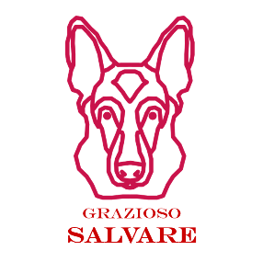
README
About The Project:
The basis behind the project is to create a fully functional and interactive web-based dashboard for an animal rescue training company. This project will be developed using the Model, View, Controller pattern.
- Model: This represents the data/database used in the backend of development
- View: This layer is the visual representation present to the user. (UI – User Interface)
- Controller: This layer handles the communication between user and data requested.
For this project, MongoDB is used for the database in the model layer. Dash Plotly, and Dash Leaflet are used in the view layer, and Python utilizing Pymongo will be used as the controller layer between MongoDB and the user.
Motivation:
Grazioso Salvare identifies dogs that are good candidates for search-and-rescue training. He has reached an agreement with a non-profit agency that operates five animal shelters around Austin, Texas. He is seeking a software application that can work with existing data from the animal shelters and categorize them into different search and rescue groups based on a combination of criteria.
Tools Used:
MongoDB – This database can be utilized for all kinds of development while offering scalable applications and flexibility to store structured or unstructured data, making it one of the most popular databases with developers. It also provides support for several different programming languages, is full technical support and documentation. MongoDB has a Python driver which gives it the full capability to produce an MVC pattern application using Python as the development language.
Dash Framework – This framework provides the view and controller structure of the web application. It is an open-source framework for building data visualization interfaces. It also supports Python which allows development between the view and controller to be handled efficiently.
Python – Python is an easy to read, learn, and write high-level programing language. It has a large variety of standard libraries and is open source making it an ideal language for developers. It works with both MongoDB and Dash providing ample driving power behind developing applications.
Python CRUD Library – You will need to create a CRUD module to use with your MongoDB utilizing the Pymongo driver. This is what will be used with the controller to handle the client server communication.
Functionality:
The functionality of this application creates an easy-to-navigate and pleasing experience for the user. Upon loading the application, the main dashboard features the Graziosos Icon which links back to the SNHU page as requested along with the dashboard's name and developer. A row of buttons is presented to the user. There are four buttons in which the user can interact with, and filter results based on Mr. Graziosos' desired results. A data table is presented below these buttons and is derived from the 5 animal shelters providing the data. Below you can see a pie chart that displays the percentage of each breed utilized in the filters. Next to that is a geo map that provides a marker to the current location of the animal selected in the data table.

Filtering Requirements:
Filtering Requirements for Rescue Dogs
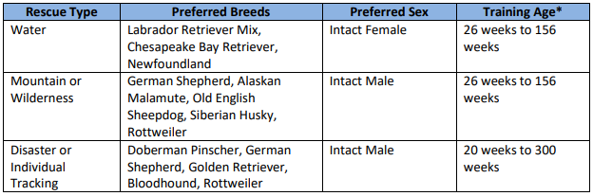
Functionality Screen Shots:
Logo with URL to homepage:
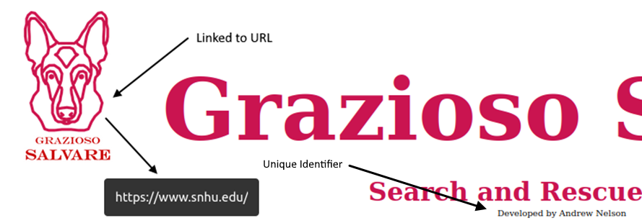

Default page loaded:
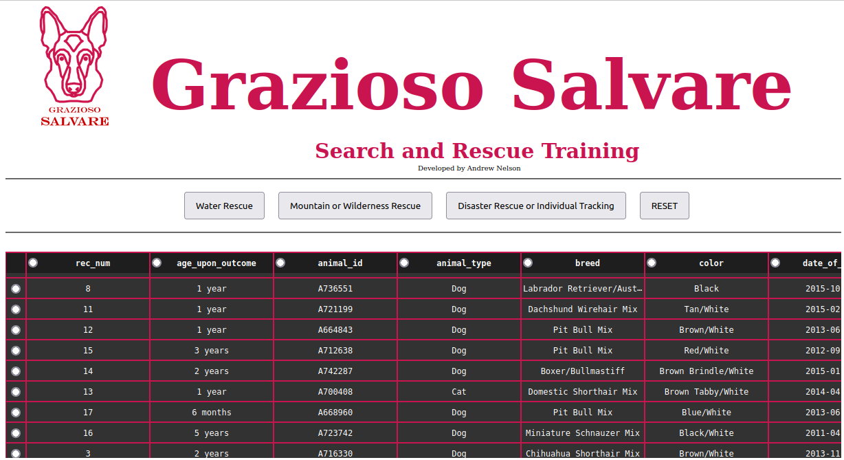
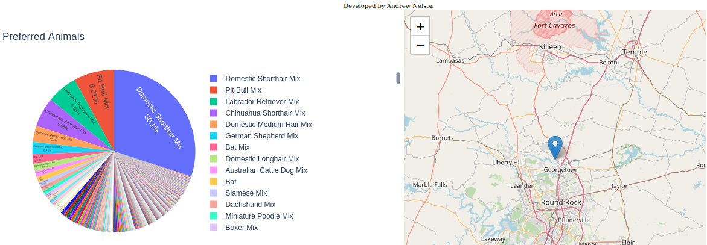

Water Rescue:
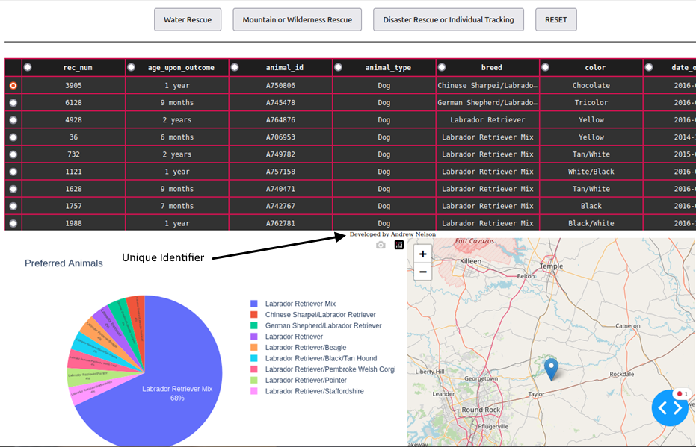
Mountain or Wilderness Rescue:
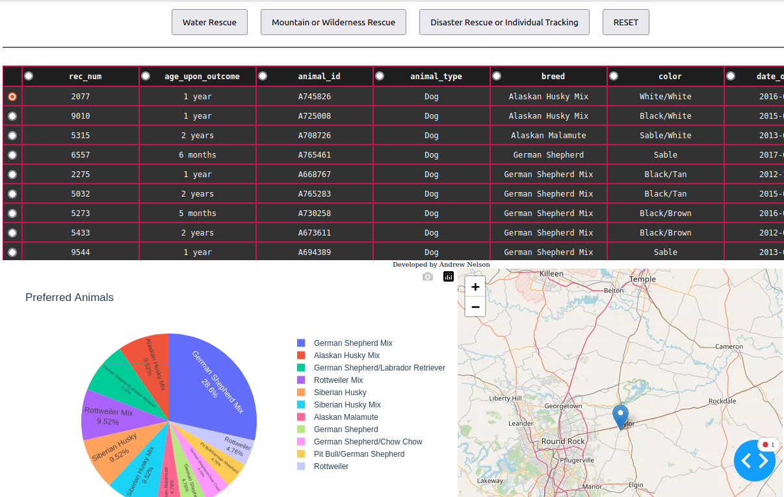

Disaster or Individual Tracking:
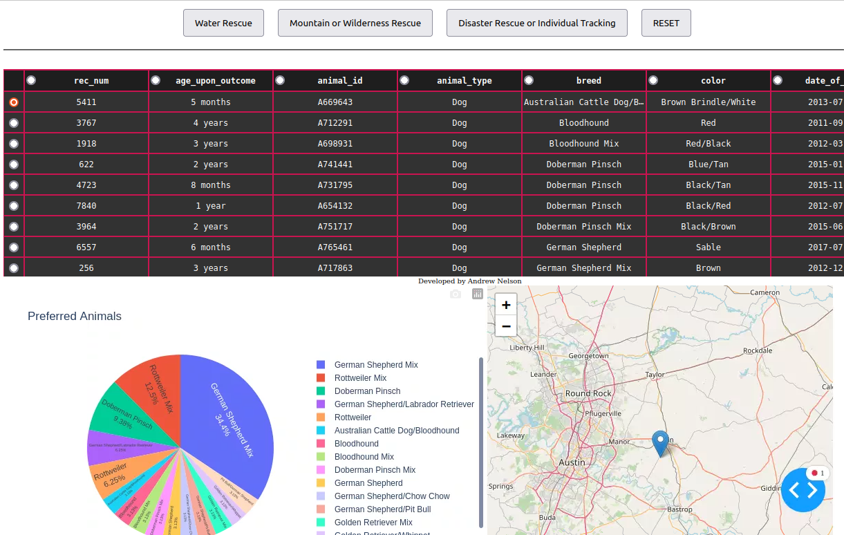
RESET: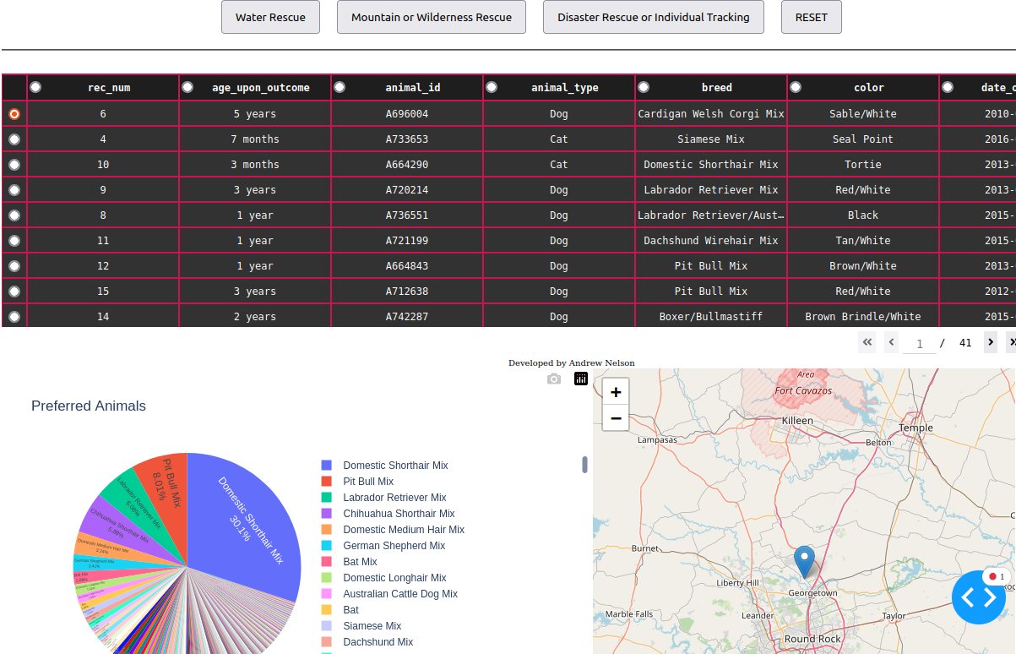
Project Creation:
To get started with the CRUD Python module you need to first set up access to your database and user authentication. This is accomplished through using mongoimport in the command line of your terminal. Here you provide your <options> <connection-string> <file> that initialize your configurations, connections method, and the file associated with the data you would like to import to the database.
After mongoimport results in a success, you get confirmation like the example below. Telling you your connection status, imported documents, and success/failure of documents imported.
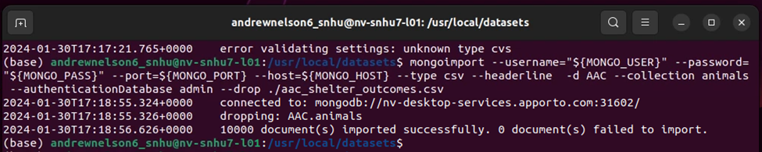Now you have access to your database. Here you can configure user access control adding users with different privileges.
Example of user authentication to the database and collection for “aacuser”:
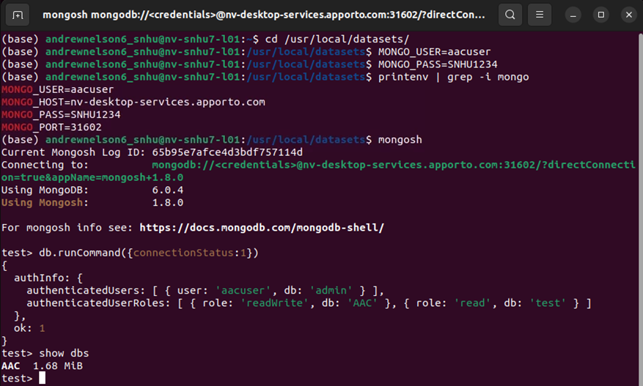
Now that you have access to your database and have users with access control you can move onto creating the Python module that will be needed as a controller between the client and database. This can be accomplished using the Python driver that utilizes Pymongo. Pymongo is a distribution of tools for interacting with the MongoDB and has methods for the MongoDB CRUD operations in Python. Specifically, you need to import MongoClient from Pymongo. MongoClient is used for making connections to MongoDB. The AnimalShelter class is initialized with your connection string, database, collection and takes username and password as parameters.
Connection Steps:
- From Pymongo import MongoClient and from bson.objectid import ObjectId
- Create MongoClient to the MongoDB instance to initialize the connection using a connection string.
- Declare your database and collection to be accessed by using attribute style access on the MongoClient instance.
Example of AnimalShelter defining MongoClient within the class for CRUD Operations.
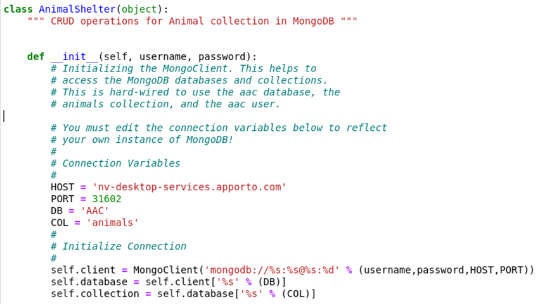
Having defined MongoClient within the class you can instantiate the AnimalShelter class by creating an instance of the class and passing your username and password as parameters for accessing MongoDB with the correct database credentials. Now you have your database set up and know how to connect to it you can start with the dashboard implementation.You will need to import several libraries along with your CRUD module to complete the dashboard.
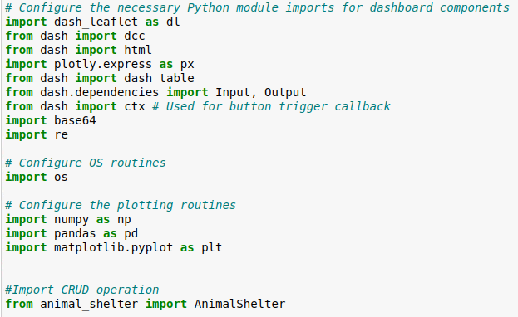
Plotly Dash, and Dash Leaflet are the two libraries used to build the interface used in this example. There are several open-source libraries that can be used in combination with these to enhance programming features.
Now that you have imported the proper libraries, you can use your CRUD module to access the data frame. Then you want to read the database into memory and store it in Panda’s Data Frame Structure as a variable. Since MongoDB automatically assigns an object id to each element of a document, we need to eliminate this column to prevent errors due to deserialization methods. You do this by dropping the column.
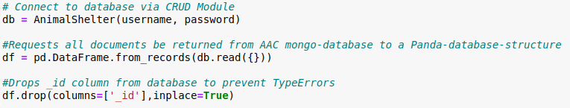
Now you can design the dashboard. To initialize the dashboard, you need to use app.layout. The application consists of 2 parts. The layout, and the callbacks. The layout is where you design the look and options of your dashboard while the callback allows you to have interactions with the data.

Add layout example:
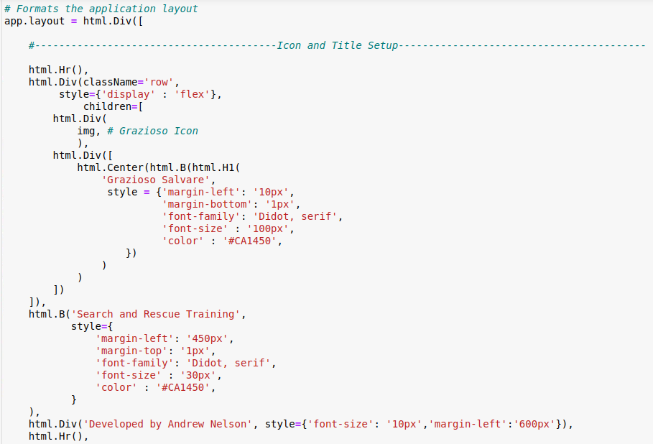
Add Dash Table Example:
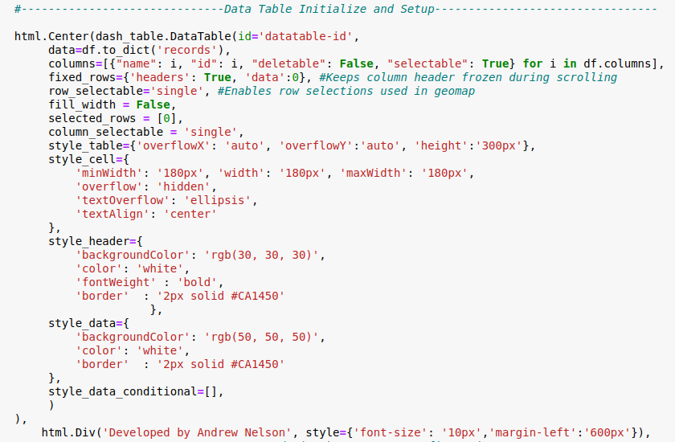

Add Callback to display pie chart when Filter buttons change:

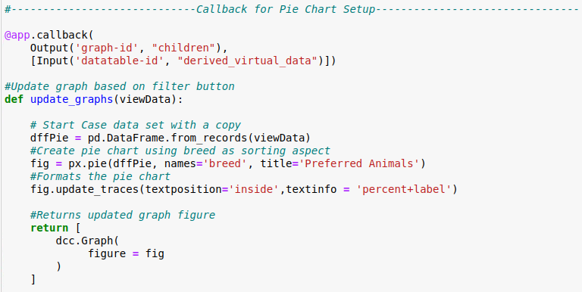

Finally, to run to application use the line app.run_server(). This will result in a link being presented in which you can click on to view your dashboard.
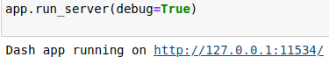
Challenges:
During the development of this application, I endured several challenges. My largest challenge was understanding the layout of the application. The dash documentation relies on CSS and HTML concepts and are all interconnected. Learning the syntax and the many different components involved in the layout took some time. I was able to overcome the challenge by watching several tutorials on dash plotly, CSS, and HTML. It then became clear how these all worked together and made the design of the layout much more intuitive. Another challenge I encountered was the button callbacks. I needed to know how to compare which button was triggered. I overcame this by re-reading the documentation on buttons and callbacks in which I discovered the ctx.trigered_id . This allowed me to simplify the logic needed to determine the correct callback output. I also struggled to get the appropriate search queries. Many of the breed names are slightly different than the proposed requirements provided by Grazioso. This resulted in some queries not producing any results such as Chesapeake Bay Retriever. This was because some of the names were shortened. There were also breeds that took the form of two dog breeds such as Labrador Retriever/Australian Cattle Dog. Due to this I used the standard library for regular expressions to effectively search for the correct breeds required.

